Attention
For the attention of the International Energy Agency and the Organisation of Economic Cooperation and Development.

Title
Does Technology Support effectively reduce Industrial Greenhouse Gas Emissions.

Purpose
The purpose of this policy brief is to investigate the relationship between the strength of technology support and greenhouse gas (GHG) emissions from the industrial sector. Consideration is given to possible negative effects on competitiveness

Executive Summary
Evaluating environmental policy across countries is difficult because a wide variety of instruments are used. The OECD Environmental Policy Stringency Indicator (EPS) addresses this by creating a comprehensive index of policy measures (Kruse et al., 2022). In this policy brief, the Technology Support Stringency is analysed for a set of 19 European Countries. Its relationship with industrial emissions reduction and competitiveness is modelled using First-Difference Ordinary Least Squares (OLS) models, as well as a Difference-in-Difference model.

Findings
- No significant association is found between Technology Support Stringency and Industrial GHG Emissions, in either the short- or long-term.
- Technology Support Stringency has no negative effect on competitiveness, measured using GDP and Patent Applications.
- Difference-in-Difference analysis of France and Germany also did not establish a link between Technology Support and Industrial Emissions.
- Modelling results were significantly influenced by the inclusion of potential cofounders, highlighting a need to enhance data availability for future analysis.
- The lack of evidence suggests further consideration of these policies is needed, and alternative market and non-market-based policies should be considered.

Background
The structure of the EPS index is shown below, where each level of branching is equally weighted in the final composition of the index:
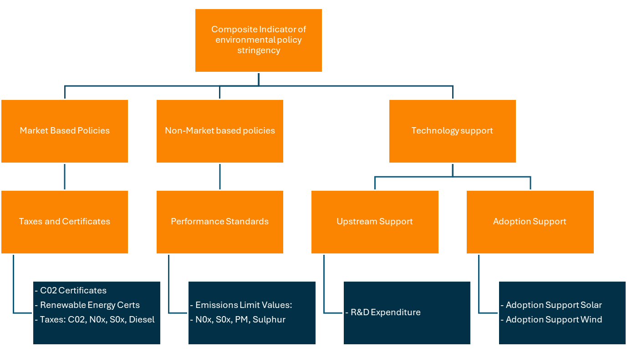
Figure 1 Source: OECD
A variety of contributions have already been made to the empirical literature using the EPS index data. Wang et al., (2020) studied the EPS impact on emissions. They found that stricter environmental policy reduced most Greenhouse Gasses (GHGs). Mihai et al., (2023) further decomposed the EPS index, using the sub-indices to find a significant influence of Market-based and Technology Support policies on GHG emissions reduction. Limited control variables were used, and the effect was not considered at an industry level. Additionally, causality was investigated using the Granger Causality test which has significant limitations and interpretability (Maziarz, 2015). A 2021 OECD review of their own empirical studies found that implementing stricter environmental policy had little aggregate effect on economic performance. The possibility was discussed that the “Low-hanging fruits of energy savings and resource reallocation might have already been exploited, and further emission reductions might require radical technology changes and vast resource reallocations” (Organisation for Economic & Development, 2021).
Porter, (1991) argued that “Strict environmental regulations do not inevitably hinder competitive advantage against foreign rivals”, instead arguing that when properly implemented they foster innovation which in turn benefits the economy. Several studies have confirmed the Porter’s hypothesis to varying extents (Morales-Lage et al., 2019). Martínez-Zarzoso et al., (2019) found association between EPS and Total Factor Productivity at all quantiles, patent applications for upper quantiles, and R&D expenditure for lower quantiles.
The literature review revealed important aspects of the EPS data, including its panel data structure, the likelihood of endogeneity, useful covariates to help control for this, possible asymmetry of the covariate distributions and the potential of a log transform to correct this. The literature supports the hypothesis that technology stringency is associated with emissions reductions, and that stringency may in fact positively impact competitiveness. A study of the relationship between emissions and technology policy industrial level is missing from the literature and analysed here. Causal evidence is limited and must be investigated further. Finally, the capital redistribution effect must be studied to investigate the possibility of a negative effect at the industrial level, even if the economy as a whole is unaffected.

Exploratory Analysis
The data covers 42 European countries from 1990 to 2022 and contains significant data gaps. Figures 1 and 2 illustrate the correlation of GHG emissions with policy stringency and GDP, emphasising the need to control for cofounders.
Figure 2 Figure 3
Figures 4 and 5 map the average trend in stringency of different policies. Tech support policies are correlated, and a more selective analysis of countries will be needed to generate heterogeneity.
Figure 4 Figure 5
Table 1 summarises the average policy stringency of the ten countries whose emissions dropped the most on average over the study period. It is noted that the Nordic countries generally had more stringent market policies, while technology supports were stronger among wealthier countries.
country | Average Annual Reduction in GHGs (%) | Market Policies | Non-Market Policies | Tech Support
Estonia | 3.3 | 1.01 | 3.33 | 2.26
Slovakia | 2.2 | 1.06 | 2.77 | 1.14
United Kingdom | 2.1 | 1.66 | 3.78 | 1.31
Czechia | 1.8 | 1.21 | 4.08 | 1.25
Germany | 1.7 | 0.96 | 4.41 | 2.17
Denmark | 1.5 | 2.42 | 3.78 | 2.05
Sweden | 1.4 | 3.21 | 3.50 | 1.46
Hungary | 1.3 | 1.21 | 3.41 | 1.57
Finland | 1.1 | 1.46 | 4.18 | 2.93
Table 1

Modelling
Modelling was restricted to the period 2008-2018 for 17 EU countries as well as Norway and the United Kingdom. One missing value was imputed using a local mean. This ensured a full set of data for analysis. The analysis period begins at the same time as Phase 2 of the EU Emissions Trading System, a cornerstone of European climate Policy. All 19 of the studied countries participated in this scheme.
Figure 6 shows a simple Ordinary Least Squares (OLS) model explaining industry emissions using policy stringency, controlling for country and year effects. The model had a high R-squared value of 0.99, but no policy term was significant. Diagnostic plots identified other issues of high multicollinearity, heteroskedasticity, and non-linear component plus residual plots.

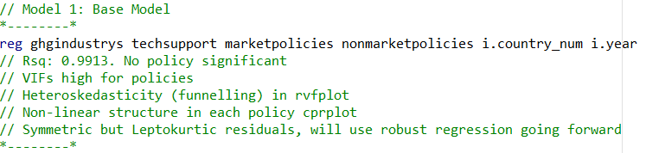
Figure 6
A variety of adjustments were made in the final model, illustrated in figure 7. A First-Difference approach was used to correct multicollinearity issues. A key adjustment was to lag the policy variables to investigate how a policy influences emissions over time. A selection procedure was used to identify significant lags, and technology support at lag one was included in the final model.
Structuring in the residual vs fitted value plot was accounted for in parameter confidence intervals using Stata’s Variance Clustering estimation technique. Difference in GHG emissions and GDP were transformed to the log scale to correct for skewed residuals, which significantly improved accuracy of the model.
Omitted variable bias is a concern for simple OLS models and may bias coefficients if not duly considered. Potential cofounders were added to isolate the effect of policy stringency on GHG emissions. Physical intuition as well as forward and backward selection procedures were used to select the final set of covariates. Using a First Difference helps with this by cancelling out country level fixed effects.
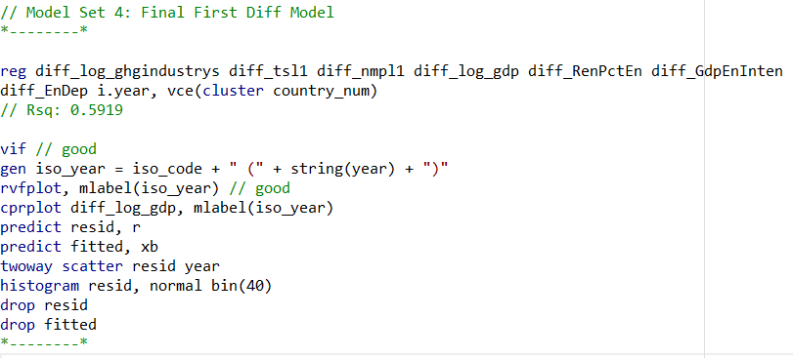
Figure 7
The adjustments successfully corrected for the structure in the residual versus fitted value plot, as illustrated in figure 8. However, technology policy at lag one was not significant at 5 or 10 percent confidence. The 95% confidence interval for the coefficient is [-0.020, 0.003]. It was noted that the coefficient was close to being significant, and a more refined country-level comparison may establish a relationship. Nevertheless, the conclusion from the cross-country level analysis was that a relationship between technology policy stringency and industrial emissions could not be established using either short-term or long-term lags of the variable.
Figure 8
The relationship between policy stringency and indicators of competitiveness was also examined. OECD patent applications data was imported and merged with the dataset. Patent applications are used as a proxy measure of competitiveness. GDP is also considered as a measure of competitiveness and growth. Figure 9 illustrates the models. No relationship was found between the response and technology stringency at any lag.
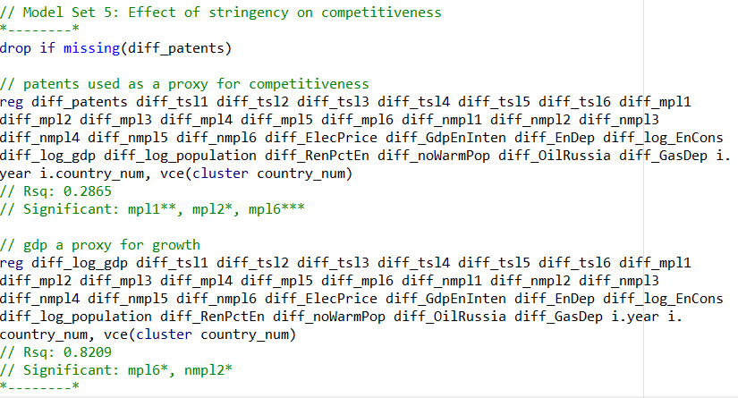
Figure 9
The First Difference model restricted country level analysis as these effects are removed by differencing. 10 and table 2 summarise the technology policy stringency of the countries analysed. Three country combinations were tested in the model, but none were significant:
- Nuclear energy vs non-nuclear energy countries
- Geographical region: Nordic, Mediterranean, Eastern European, Western European.
- Euro currency countries. A t-test was used to test the alternative hypothesis that log of GHG industrial emissions will be different for Euro-area countries that non-euro area countries. A test statistic of 0.47 was obtained, which is not significant at 5% (two-sided p-value of 0.64)
.
Figure 10
Country | Average Tech Support Stringency 2008-2018
France | 4.57
Luxembourg | 4.52
Finland | 3.86
Estonia | 3.48
Netherlands | 3.45
Italy | 3.41
Denmark | 3.18
Austria | 3.14
Germany | 2.91
Greece | 2.67
Hungary | 2.41
Slovakia | 2.34
Czechia | 2.27
United Kingdom | 2.23
Slovenia | 1.98
Belgium | 1.68
Sweden | 1.59
Portugal | 1.57
Ireland | 1.39
Spain | 1.27
Poland | 0.95
Table 2
Finally, a Difference-in-Difference approach was employed to attempt to establish a causal relationship on a two-country level. France and Germany were identified for comparison. The two industrial powerhouses of Europe have dad similar overall policy developments under EU frameworks and emissions trading. This assumption of similarity is necessary to establish causality. Figure 11 illustrates the annual change in industrial emissions over a six-year period. In 2013 Germany announced a comprehensive package of environmental reforms, notably increasing technology support (Figure 12) and providing a basis for the Difference-in-Difference approach
Figure 11 Figure 12
The model was fitted and no Difference-in-Difference effect was found from the year 2013. The fitted effect was close to zero, with a 95% confidence interval of [-0.158, 0.157]. No causal relationship was identified in this case.
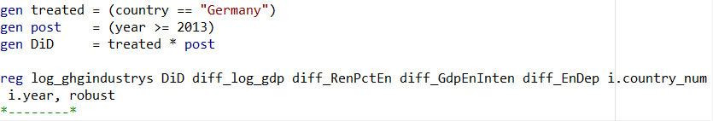
Figure 13

Limitations and Next Steps
The analysis was limited by data availability. Complete data was only available for a ten-year stretch. It is possible that technology policy takes effect over a much longer time frame.
Another limitation was the choice of a First Difference model. This removed country effects, which are interesting to analyse in their own right. Further analysis should address policy on a country-by-country level. The Difference-in-Difference model began this work, but significantly more analysis is needed.
Finally, the heterogeneity by introducing countries outside Europe may enable identification of a stronger relationship between emissions and technology stringency. Overall, the conclusion is that further analysis is needed. While technology support stringency did not harm competitiveness, it was also only weakly associated with a reduction of industrial emissions.

Bibliography
Kruse, T., Dechezleprêtre, A., Saffar, R., & Robert, L. (2022). Measuring environmental policy stringency in OECD countries: An update of the OECD composite EPS indicator [techreport](1703). (OECD Economics Department Working Papers, Issue. https://www.oecd.org/en/publications/measuring-environmental-policy-stringency-in-oecd-countries_90ab82e8-en.html
Martı́nez-Zarzoso, I., Bengochea-Morancho, A., & Morales-Lage, R. (2019). Does Environmental Policy Stringency Foster Innovation and Productivit y in OECD Countries? Energy Policy, 134, 110982. https://doi.org/10.1016/j.enpol.2019.110982
Maziarz, M. (2015). A review of the Granger-causality fallacy. The Journal of Philosophical Economics: Reflections on Economic and So cial Issues, VIII(2), 86-105. https://hrcak.srce.hr/155919
Mihai, D. M., Doran, M. D., Puiu, S., Doran, N. M., Jianu, E., & Cojocaru, T. M. (2023). Managing Environmental Policy Stringency to Ensure Sustainable Develop ment in OECD Countries. Sustainability, 15(21), 15427. https://doi.org/10.3390/su152115427
Morales-Lage, R., Bengochea Morancho, A., & Martı́nez-Zarzoso, I. (2019). Does environmental policy stringency foster innovation and productivit y in OECD countries? Energy Policy, 134, 110982. https://doi.org/10.1016/j.enpol.2019.110982
Organisation for Economic, C.-o., & Development. (2021). Assessing the Economic Impacts of Environmental Policies: Evidence fro m a Decade of OECD Research [techreport]. https://www.oecd.org/environment/assessing-the-economic-impacts-of-environmental-policies-bf2fb156-en.htm
Porter, M. E. (1991). America’s Green Strategy. Scientific American, 264(4), 168. https://doi.org/10.1038/scientificamerican0491-168
Wang, K., Yan, M., Wang, Y., & Chang, C.-P. (2020). The impact of environmental policy stringency on air quality. Atmospheric Environment, 231, 117522. https://doi.org/10.1016/j.atmosenv.2020.117522

Appendix – Stata Do File

*** STATISTICS FOR PUBLIC POLICY - FINAL ASSESSMENT ***

// Setup
*--------*
// clear all data and commands in use
clear all

// close any log file in use
capture log close

// so there is no break when command is running
set more off

// set working directory
cd "xxx"

// start a new log file, it is saved in your working directory
log using final_assessment_log.log, text replace

// Load Data, removing any data already loaded beforehand
use "Option 2 Dataset.dta", clear

// plotting preferences
set scheme s2color // s1color, s2color, economist, plotplain
graph set window fontface "Arial"
*--------*

// Add patent data from OECD
*--------*
// source: https://sdmx.oecd.org/public/rest/data/OECD.STI.PIE,DSD_PATENTS@DF_PATENTS,1.0/.A.AP.PATN.PRIORITY.AUT+BEL+CZE+DNK+EST+FIN+FRA+DEU+GRC+HUN+ISL+IRL+ITA+LVA+LTU+LUX+NLD+NOR+POL+PRT+SVK+SVN+ESP+SWE+CHE+TUR+GBR+BLR+ARM+BGR+HRV+CYP+MDA+ROU..INVENTOR...ENV_TECH?startPeriod=2008&endPeriod=2018&dimensionAtObservation=AllDimensions
import excel "Patents.xlsx", firstrow clear
merge 1:1 country year using "Option 2 Dataset.dta"
// clean
replace EuropeanPatentOffice = subinstr(EuropeanPatentOffice, " ", "", .)
replace EuropeanPatentOffice = ustrregexra(EuropeanPatentOffice, "\u00A0", "")
destring EuropeanPatentOffice, replace
replace WorldIntellectualPropertyOrga = subinstr(WorldIntellectualPropertyOrga, " ", "", .)
replace WorldIntellectualPropertyOrga = ustrregexra(WorldIntellectualPropertyOrga, "\u00A0", "")
destring WorldIntellectualPropertyOrga, replace
replace UnitedStatesPatentandTradema = subinstr(UnitedStatesPatentandTradema, " ", "", .)
replace UnitedStatesPatentandTradema = ustrregexra(UnitedStatesPatentandTradema, "\u00A0", "")
destring UnitedStatesPatentandTradema, replace
// aggregate
gen total_patents = EuropeanPatentOffice + WorldIntellectualPropertyOrga + UnitedStatesPatentandTradema
*--------*

/// SECTION 1: EXPLORATORY ANALYSIS ///

// Data Prep
*--------*
//encode country as a factor variable
encode country, gen(country_num)

// create a panel setup in Stata; allows me to create lags easily
xtset country_num year

// Check countries there is data for
levelsof country // missing 3 European countries: Armenia, Azerbaijan, Belarus

// Create variables used in modelling

// high level variables
gen diff_patents = d.total_patents
gen diff_ghg = d.ghgtotalnolulucf
gen diff_co2 = d.co2totalnolulucf
gen diff_methane = d.methanetotalnolulucf
gen diff_nox = d.noxtotalnolulucf
gen diff_sulpher = d.sulphurtotalnolulucf
gen diff_eps = d.eps
gen diff_epsl1 = L.diff_eps
gen diff_epsl2 = L2.diff_eps
gen diff_epsl3 = L3.diff_eps
gen diff_epsl4 = L4.diff_eps
gen diff_epsl5 = L5.diff_eps
gen diff_epsl6 = L6.diff_eps
// response of interest
gen diff_ghgindustrys = d.ghgindustrys
gen log_ghgindustrys = ln(ghgindustrys)
gen diff_log_ghgindustrys = d.log_ghgindustrys
// independent variables of interest
gen diff_mp = d.marketpolicies
gen diff_mpl1 = L.diff_mp
gen diff_mpl2 = L2.diff_mp
gen diff_mpl3 = L3.diff_mp
gen diff_mpl4 = L4.diff_mp
gen diff_mpl5 = L5.diff_mp
gen diff_mpl6 = L6.diff_mp
gen diff_nmp = d.nonmarketpolicies
gen diff_nmpl1 = L.diff_nmp
gen diff_nmpl2 = L2.diff_nmp
gen diff_nmpl3 = L3.diff_nmp
gen diff_nmpl4 = L4.diff_nmp
gen diff_nmpl5 = L5.diff_nmp
gen diff_nmpl6 = L6.diff_nmp
gen diff_ts = d.techsupport
gen diff_tsl1 = L.diff_ts
gen diff_tsl2 = L2.diff_ts
gen diff_tsl3 = L3.diff_ts
gen diff_tsl4 = L4.diff_ts
gen diff_tsl5 = L5.diff_ts
gen diff_tsl6 = L6.diff_ts
// impute one missing value: elecpricenohhtax_perkwh in italy in 2007
// Value doesn't trend a huge amount so I'll just replace with the 2008-2011 mean
replace elecpricenohhtax_perkwh = 0.1714 if country == "Italy" & year == 2007
// controls
gen diff_ElecPrice = d.elecpricenohhtax_perkwh
gen diff_GdpEnInten = d.energy_per_gdp
gen diff_EnDep = d.energydependence_totalpercentage
gen diff_EnCons = d.final_energy_consum_mtonoilequi
gen diff_GasPrice = d.gaspricenohhtax_perkwh
gen diff_gdp = d.gdp
gen diff_heatpump = d.heatpumps_installcap_GW
gen diff_pop = d.population
gen diff_RenPctEn = d.rentotalenergy_perc
gen diff_noWarmPop = d.nowarmpopulation_perc
gen diff_OilRussia = d.oilrussia_000ton
gen diff_GasDep = d.naturalgasdependecy_percentage
gen diff_GasDepRussia = d.NGdepenRussia_perc
// logs
gen log_gdp = ln(gdp)
gen diff_log_gdp = d.log_gdp
gen log_EnCons = ln(final_energy_consum_mtonoilequi)
gen diff_log_EnCons = d.log_EnCons
gen log_GdpEnInten = ln(energy_per_gdp)
gen diff_log_GdpEnInten = d.log_GdpEnInten
gen log_heatpump = ln(heatpumps_installcap_GW)
gen diff_log_heatpump = d.log_heatpump
gen log_population = ln(population)
gen diff_log_population = d.log_population
gen log_OilRussia = ln(oilrussia_000ton)
gen diff_log_OilRussia = d.log_OilRussia
*--------*

// Plot pct change in GHG emissions vs Policy Stringency
*--------*
//egen ghg_pct_change_z = std(ghg_pct_change)
//egen eps_z = std(eps)

twoway ///
(scatter ghg_pct_change eps, mcolor(navy) msymbol(circle)) ///
(lfit ghg_pct_change eps, lcolor(black) lwidth(medthick)), ///
title("GHG Annual Change vs Policy Stringency") ///
xtitle("Policy Stringency Score") ///
ytitle("Annual % Change in GHG Emissions") ///
graphregion(color(white)) plotregion(lcolor(none)) ///
legend(off)

// graph export Plots/f1_GhgpctVsEps.pdf, replace
*--------*

// Plotting year against GHG Emisssions: a significant cofounder
*--------*
//egen ghg_pct_change_z = std(ghg_pct_change)
//egen eps_z = std(eps)

twoway ///
(scatter ghg_pct_change gdpgrowthmkprice_percentpc, ///
mcolor(navy) msymbol(circle)) ///
(lfit ghg_pct_change gdpgrowthmkprice_percentpc, lcolor(black) lwidth(medthick)), ///
title("GHG Emissions by GDP") ///
xtitle("Real Annual GDP Growth per Capita %") ///
ytitle("Annual Change in GHG Emissions %") ///
graphregion(color(white)) plotregion(lcolor(none)) ///
legend(off)

graph export Plots/f2_GhgpctVsGdpgrowthmkpricepercentpcp.pdf, replace
*--------*

// Zone in on one country to see how stringency and emissions varied with time
*--------*
//egen ghg_pct_change_z = std(ghg_pct_change)
//egen eps_z = std(eps)

twoway ///
(scatter ghg_pct_change year if country == "Germany", ///
mcolor(navy) msymbol(circle)) ///
(lfit ghg_pct_change year, lcolor(black) lwidth(medthick)), ///
title("GHG Annual Change vs Policy Stringency") ///
xtitle("Year") ///
ytitle("Annual % Change in GHG Emissions") ///
graphregion(color(white)) plotregion(lcolor(none)) ///
legend(off)

twoway ///
(scatter eps year if country == "Germany", ///
mcolor(navy) msymbol(circle)) ///
(lfit eps year, lcolor(black) lwidth(medthick)), ///
title("GHG Annual Change vs Policy Stringency") ///
xtitle("Year") ///
ytitle("Policy Stringency Score") ///
graphregion(color(white)) plotregion(lcolor(none)) ///
legend(off)

twoway ///
(scatter ghg_pct_change eps if country == "Germany", ///
mcolor(navy) msymbol(circle)) ///
(lfit ghg_pct_change eps, lcolor(black) lwidth(medthick)), ///
title("GHG Annual Change vs Policy Stringency") ///
xtitle("Policy Stringency Score") ///
ytitle("Annual % Change in GHG Emissions") ///
graphregion(color(white)) plotregion(lcolor(none)) ///
legend(off)

//graph export Plots/f1_GhgpctVsEps.pdf, replace
*--------*

// Plot stringency over time, broken down into categories
*--------*
//egen ghg_pct_change_z = std(ghg_pct_change)
//egen eps_z = std(eps)

// marketpolicies, nonmarketpolicies, techsupport
preserve
collapse (mean) marketpolicies nonmarketpolicies techsupport, by(year)

twoway ///
(line marketpolicies year, lcolor("#F08700") lwidth(medthick)) ///
(line nonmarketpolicies year, lcolor("#EFCA08") lwidth(medthick)) ///
(line techsupport year, lcolor("#00A6A6") lwidth(medthick)), ///
xtitle("Year") ytitle("Average Stringency") ///
title("Policy Stringency Over Time") ///
legend(order(1 "Market Policies" 2 "Non-Market Policies" 3 "Tech Support")) ///
graphregion(color(white)) ///
plotregion(lcolor(none))

graph export Plots/f3_StringencyOverTime.pdf, replace
restore
*--------*

// Plot Tech Policy Stringency over time
*--------*
// lowco2rdexp solartenfit windtenfit
preserve
collapse (mean) lowco2rdexp solartenfit windtenfit, by(year)

twoway ///
(line lowco2rdexp year, lcolor("#F08700") lwidth(medthick)) ///
(line solartenfit year, lcolor("#EFCA08") lwidth(medthick)) ///
(line windtenfit year, lcolor("#00A6A6") lwidth(medthick)), ///
xtitle("Year") ytitle("Average Stringency") ///
title("Technology Support Policy Stringency Over Time") ///
legend(order(1 "R&D Expenditure" 2 "Solar Support" 3 "Wind Support")) ///
graphregion(color(white)) ///
plotregion(lcolor(none))

graph export Plots/f4_TechStringencyOverTime.pdf, replace
restore
*--------*

// Country variations
*--------*
preserve

// create summary statistics for policy stringency and GDP changes
collapse ///
(mean) gdp ghg_pct_change marketpolicies nonmarketpolicies techsupport ///
(sd) gdp_sd = gdp ghg_pct_change_sd = ghg_pct_change marketpolicies_sd = marketpolicies nonmarketpolicies_sd = nonmarketpolicies techsupport_sd = techsupport, ///
by(country)

// export table to excel
export excel using "countryLevelStats.xlsx", replace

restore
*--------*

// SECTION 3: Modelling

// Key variables
*--------*
// response: ghgindustrys; co2industrys methaneindustrys noxindustrys sulphurindustrys
// variable of interest: techsupport; windtenfit solartenfit lowco2rdexp
// variable of interest (granular): windfit_lenght wastefit_length shydrofit_length pvfit_lengths marinefit_length geofit_length biomassfit_length
// controls: marketpolicies nonmarketpolicies country elecpricenohhtax_perkwh energy_per_gdp energydependence_totalpercentage final_energy_consum_mtonoilequi gaspricenohhtax_perkwh gdp heatpumps_installcap_GW population rentotalenergy_perc year
// extra considerations: nowarmpopulation_perc oilrussia_000ton naturalgasdependecy_percentage NGdepenRussia_perc
*--------*

// Data prep
*--------*
// filter to subset of countries with data
keep if year >= 2008 & year <= 2018
drop if missing(eps)
drop if inlist(country, "Türkiye", "Greece", "Austria", "Iceland", "Switzerland", "Estonia")
// export tech support data
table country year, statistic(mean techsupport)
collect export "techsupport_table.xlsx", replace
*--------*

// Diagnostics for each model run
*--------*
vif
gen iso_year = iso_code + " (" + string(year) + ")"
rvfplot, mlabel(iso_year)
cprplot diff_nmpl1
predict resid, r
predict fitted, xb
twoway scatter resid year
histogram resid, normal bin(30)
drop resid
drop fitted
*--------*

// Model 1: Base Model
*--------*
reg ghgindustrys techsupport marketpolicies nonmarketpolicies i.country_num i.year
// Rsq: 0.9913. No policy significant
// VIFs high for policies
// Heteroskedasticity (funnelling) in rvfplot
// Non-linear structure in each policy cprplot
// Symmetric but Leptokurtic residuals, will use robust regression going forward
*--------*

// Model Set 2: First-Diff Model
*--------*
reg diff_ghgindustrys diff_ts diff_mp diff_nmp i.year, robust
// Rsq: 0.3514. no policy significant
// VIF no longer high for policies
// Clear structure in rvfplot but no funnelling, use clustered residuals
// also use log of ghg to correct rvfplot
// Possible structure in each policy cprplot
// negatively skewed residuals
*--------*

// Model Set 3: Introduce Policy Lags to test longer-term relationship
*--------*

reg diff_log_ghgindustrys diff_tsl1 diff_mpl1 diff_nmpl1 i.year, vce(cluster country_num)
// Rsq: 0.5558. None significant
reg diff_log_ghgindustrys diff_tsl1 diff_tsl2 diff_tsl3 diff_tsl4 diff_tsl5 diff_tsl6 diff_mpl1 diff_nmpl1 i.year, vce(cluster country_num)
// Rsq: 0.5647. TS not sig at any lag; relationship weak
reg diff_log_ghgindustrys diff_mpl1 diff_mpl2 diff_mpl3 diff_mpl4 diff_mpl5 diff_mpl6 diff_tsl1 diff_nmpl1 i.year, vce(cluster country_num)
// Rsq: 0.5661, mpl2*
reg diff_log_ghgindustrys diff_nmpl1 diff_nmpl2 diff_nmpl3 diff_nmpl4 diff_nmpl5 diff_nmpl6 diff_tsl1 diff_mpl1 i.year, vce(cluster country_num)
// Rsq: 0.5659, none significant

// check what forward and backward stepwise regression produce
stepwise, pr(.10): reg diff_log_ghgindustrys diff_tsl1 diff_tsl2 diff_tsl3 diff_tsl4 diff_tsl5 diff_tsl6 diff_mpl1 diff_mpl2 diff_mpl3 diff_mpl4 diff_mpl5 diff_mpl6 diff_nmpl1 diff_nmpl2 diff_nmpl3 diff_nmpl4 diff_nmpl5 diff_nmpl6 i.year, vce(cluster country_num)
// tsl1
stepwise, pe(.10): reg diff_log_ghgindustrys diff_tsl1 diff_tsl2 diff_tsl3 diff_tsl4 diff_tsl5 diff_tsl6 diff_mpl1 diff_mpl2 diff_mpl3 diff_mpl4 diff_mpl5 diff_mpl6 diff_nmpl1 diff_nmpl2 diff_nmpl3 diff_nmpl4 diff_nmpl5 diff_nmpl6 i.year, vce(cluster country_num)
// mpl2, tsl1, mpl4, nmpl5
// Need covariates and country trends to get a clearer picture
*--------*

// Model Set 4: Introduce Controls & Country Trends
*--------*
// controls
// diff_ElecPrice diff_GdpEnInten diff_EnDep diff_EnCons diff_gdp diff_pop diff_RenPctEn diff_noWarmPop diff_OilRussia diff_GasDep
// logged controls
// diff_log_gdp diff_log_EnCons diff_log_GdpEnInten diff_log_population diff_log_OilRussia diff_log_gdp

// play around with logs to see which works best for each variable
reg diff_log_ghgindustrys diff_tsl1 diff_tsl2 diff_tsl3 diff_tsl4 diff_tsl5 diff_tsl6 diff_mpl1 diff_mpl2 diff_mpl3 diff_mpl4 diff_mpl5 diff_mpl6 diff_nmpl1 diff_nmpl2 diff_nmpl3 diff_nmpl4 diff_nmpl5 diff_nmpl6 diff_ElecPrice diff_GdpEnInten diff_EnDep diff_log_EnCons diff_log_gdp diff_log_population diff_RenPctEn diff_noWarmPop diff_OilRussia diff_GasDep i.year, vce(cluster country_num)
// Rsq: 0.6348
// Significant: nmpl1* GdpEnInten* log_gdp**

// variable selection
stepwise, pr(.10): reg diff_log_ghgindustrys diff_tsl1 diff_tsl2 diff_tsl3 diff_tsl4 diff_tsl5 diff_tsl6 diff_mpl1 diff_mpl2 diff_mpl3 diff_mpl4 diff_mpl5 diff_mpl6 diff_nmpl1 diff_nmpl2 diff_nmpl3 diff_nmpl4 diff_nmpl5 diff_nmpl6 diff_ElecPrice diff_GdpEnInten diff_EnDep diff_log_EnCons diff_log_gdp diff_log_population diff_RenPctEn diff_noWarmPop diff_OilRussia diff_GasDep i.year, vce(cluster country_num)
// Rsq: 0.5849. diff_tsl1 nmpl6 diff_log_gdp RenPctEn
stepwise, pe(.10): reg diff_log_ghgindustrys diff_tsl1 diff_tsl2 diff_tsl3 diff_tsl4 diff_tsl5 diff_tsl6 diff_mpl1 diff_mpl2 diff_mpl3 diff_mpl4 diff_mpl5 diff_mpl6 diff_nmpl1 diff_nmpl2 diff_nmpl3 diff_nmpl4 diff_nmpl5 diff_nmpl6 diff_ElecPrice diff_GdpEnInten diff_EnDep diff_log_EnCons diff_log_gdp diff_log_population diff_RenPctEn diff_noWarmPop diff_OilRussia diff_GasDep i.year, vce(cluster country_num)
// Rsq: 0.5470 log_gdp GdpEnInten EnDep GasDep tsl2 nmpl1 RenPctEn

// Final covariate focus: log_gdp RenPctEn GdpEnInten EnDep

// Exploring country trend and groupings
// (note interpretation of this in a first diff model)

// "Finland" "Sweden" "Netherlands" "Denmark"
// "Poland" "Czechia" "Estonia" "Slovenia" "Slovakia" "Hungary" "Greece"
// "Belgium" "Germany" "France" "Spain" "Portugal" "Luxembourg" "Ireland" "Austria" "United Kingdom" "Italy"

// inital tests
reg diff_log_ghgindustrys diff_tsl1 diff_tsl2 diff_tsl3 diff_tsl4 diff_tsl5 diff_tsl6 diff_mpl1 diff_mpl2 diff_mpl3 diff_mpl4 diff_mpl5 diff_mpl6 diff_nmpl1 diff_nmpl2 diff_nmpl3 diff_nmpl4 diff_nmpl5 diff_nmpl6 diff_log_gdp diff_RenPctEn diff_GdpEnInten diff_EnDep i.country_num i.year, vce(cluster country_num)
stepwise, pr(.10): reg diff_log_ghgindustrys diff_tsl1 diff_tsl2 diff_tsl3 diff_tsl4 diff_tsl5 diff_tsl6 diff_mpl1 diff_mpl2 diff_mpl3 diff_mpl4 diff_mpl5 diff_mpl6 diff_nmpl1 diff_nmpl2 diff_nmpl3 diff_nmpl4 diff_nmpl5 diff_nmpl6 diff_log_gdp diff_RenPctEn diff_GdpEnInten diff_EnDep i.country_num i.year, vce(cluster country_num)
stepwise, pe(.10): reg diff_log_ghgindustrys diff_tsl1 diff_tsl2 diff_tsl3 diff_tsl4 diff_tsl5 diff_tsl6 diff_mpl1 diff_mpl2 diff_mpl3 diff_mpl4 diff_mpl5 diff_mpl6 diff_nmpl1 diff_nmpl2 diff_nmpl3 diff_nmpl4 diff_nmpl5 diff_nmpl6 diff_log_gdp diff_RenPctEn diff_GdpEnInten diff_EnDep i.country_num i.year, vce(cluster country_num)

// plot tech support over time for each country
preserve
levelsof country_num, local(countries)
local plots
local i = 1
foreach c of local countries {
local lbl : label (country_num) `c'
local plots `plots' ///
(line techsupport year if country_num == `c', legend(label(`i' "`lbl'")))
local ++i
}
twoway `plots', ///
xtitle("Year") ///
ytitle("Tech Support Stringency") ///
title("Tech Support Policy Stringency by Country") ///
legend( ///
cols(3) ///
size(small) ///
position(3) ///
ring(1) ///
) ///
graphregion(color(white))
graph export Plots/f5_TechSupport_ByCountry.pdf, replace
restore

// Group by Nuclear Countries
gen nuclear_2008_2018 = 0
replace nuclear_2008_2018 = 1 if ///
inlist(country,"Finland","Sweden","Netherlands","Czechia","Slovenia") | ///
inlist(country,"Slovakia","Hungary","Belgium","Germany","France") | ///
inlist(country,"Spain","United Kingdom")

reg diff_log_ghgindustrys diff_tsl1 diff_mpl1 diff_nmpl1 diff_log_gdp diff_RenPctEn diff_GdpEnInten diff_EnDep nuclear_2008_2018 i.year, vce(cluster country_num)
// nuclear not significant

// group by geographical region

gen nordic = 0
gen mediterranean = 0
gen eastern_europe = 0
gen western_europe = 0
replace nordic = 1 if ///
inlist(country,"Finland","Sweden","Denmark")
replace mediterranean = 1 if ///
inlist(country,"Spain","Italy","Greece")
replace eastern_europe = 1 if ///
inlist(country,"Poland","Czechia","Slovakia","Hungary","Estonia","Slovenia")
replace western_europe = 1 if ///
inlist(country,"Netherlands","Belgium","Germany","France","Austria","Luxembourg","Ireland","United Kingdom","Portugal")

// leave western_europe out as base category
reg diff_log_ghgindustrys diff_tsl1 diff_mpl1 diff_nmpl1 diff_log_gdp diff_RenPctEn diff_GdpEnInten diff_EnDep nordic mediterranean eastern_europe i.year, vce(cluster country_num)
// none significant

// Group by Euro countries
gen euro = 0
replace euro = 1 if ///
inlist(country,"Finland","Netherlands","Slovenia","Slovakia","Estonia") | ///
inlist(country,"Belgium","Germany","France","Spain","Ireland") | ///
inlist(country,"Austria","Portugal","Luxembourg","Italy")

reg diff_log_ghgindustrys diff_tsl1 diff_mpl1 diff_nmpl1 diff_log_gdp diff_RenPctEn diff_GdpEnInten diff_EnDep euro i.year, vce(cluster country_num)
// not significant

collapse (mean) log_ghgindustrys, by(country year euro)
ttest log_ghgindustrys, by(euro)
*--------*

// Model Set 4: Final First Diff Model
*--------*

reg diff_log_ghgindustrys diff_tsl1 diff_nmpl1 diff_log_gdp diff_RenPctEn diff_GdpEnInten diff_EnDep i.year, vce(cluster country_num)
// Rsq: 0.5919

vif // good
gen iso_year = iso_code + " (" + string(year) + ")"
rvfplot, mlabel(iso_year) /// good
graphregion(color(white)) ///
plotregion(lcolor(none))
graph export Plots/f6_RVF.pdf, replace

cprplot diff_log_gdp, mlabel(iso_year)
predict resid, r
predict fitted, xb
twoway scatter resid year
histogram resid, normal bin(40)
drop resid
drop fitted
*--------*

// Model Set 5: Effect of stringency on competitiveness
*--------*
drop if missing(diff_patents)

// patents used as a proxy for competitiveness
reg diff_patents diff_tsl1 diff_tsl2 diff_tsl3 diff_tsl4 diff_tsl5 diff_tsl6 diff_mpl1 diff_mpl2 diff_mpl3 diff_mpl4 diff_mpl5 diff_mpl6 diff_nmpl1 diff_nmpl2 diff_nmpl3 diff_nmpl4 diff_nmpl5 diff_nmpl6 diff_ElecPrice diff_GdpEnInten diff_EnDep diff_log_EnCons diff_log_gdp diff_log_population diff_RenPctEn diff_noWarmPop diff_OilRussia diff_GasDep i.year i.country_num, vce(cluster country_num)
// Rsq: 0.2865
// Significant: mpl1**, mpl2*, mpl6***

// gdp a proxy for growth
reg diff_log_gdp diff_tsl1 diff_tsl2 diff_tsl3 diff_tsl4 diff_tsl5 diff_tsl6 diff_mpl1 diff_mpl2 diff_mpl3 diff_mpl4 diff_mpl5 diff_mpl6 diff_nmpl1 diff_nmpl2 diff_nmpl3 diff_nmpl4 diff_nmpl5 diff_nmpl6 diff_ElecPrice diff_GdpEnInten diff_EnDep diff_log_EnCons diff_log_population diff_RenPctEn diff_noWarmPop diff_OilRussia diff_GasDep i.year i.country_num, vce(cluster country_num)
// Rsq: 0.8209
// Significant: mpl6*, nmpl2*
*--------*

// Model Set 6: DiD
*--------*

keep if year >= 2010 & year <= 2016

twoway ///
(line diff_ghgindustrys year if country=="France", lpattern(solid)) ///
(line diff_ghgindustrys year if country=="Germany", lpattern(dash)), ///
legend(order(1 "France" 2 "Germany")) ///
ytitle("GHG emissions (MtC02e)") ///
title("Annual Change in GHG Emissions") ///
graphregion(color(white)) ///
plotregion(lcolor(none))

twoway ///
(line techsupport year if country=="France", lpattern(solid)) ///
(line techsupport year if country=="Germany", lpattern(dash)), ///
legend(order(1 "France" 2 "Germany")) ///
ytitle("Tech Support Stringency") ///
title("Annual Change in Technology Support") ///
graphregion(color(white)) ///
plotregion(lcolor(none))

keep if inlist(country, "Germany", "France")

gen treated = (country == "Germany")
gen post = (year >= 2013)
gen DiD = treated * post

reg log_ghgindustrys DiD diff_log_gdp diff_RenPctEn diff_GdpEnInten diff_EnDep i.country_num i.year, robust
*--------*

